|  |
| --- |
| ***Lab Report***  ***IA 3203 – Digital Signal Processing***  *Department of Instrumentation and Automation Technology*  *University of Colombo* |
| **DSP 302 – Analog Filters using Octave** |

|  |  |
| --- | --- |
| **Registration No: 2021t01108** |  |
| **Students Name: G.G.B.S Gunawardana** |  |
| **Date (dd/mm/yy): 26/07/2024** |  |

**Exercise:**

Question 01:

**Answer:**

***Octave code:***

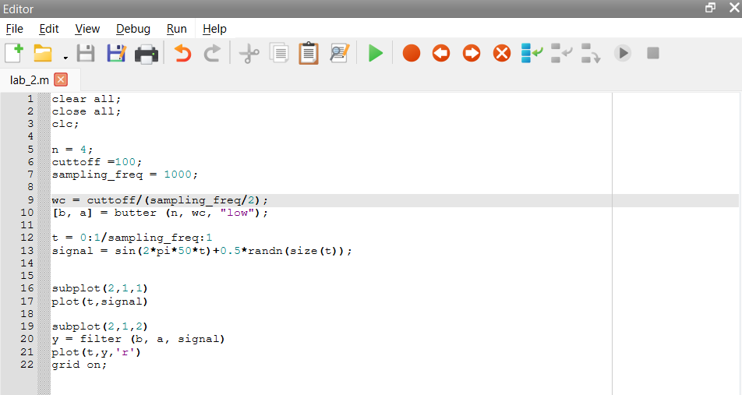

***Figures:***

***Results/Answers in Command Window:***

Question 02:

* Smooth response at all frequencies.
* Monotonic decrease from the specified cut-off frequencies.
* Maximal flatness, with the ideal response of unity in the passband and zero in the stopband.
* Half-power frequency, or 3 dB down frequency, that corresponds to the specified cut-off frequencies

Question 03:

* In equalizers
* In crossovers
* In signal processing applications
* In control systems for feedback control